**SAVEETHA SCHOOL OF ENGINEERING**

**CSA1142-OBJECT ORIENTED ANALYSIS AND DESIGN**

**QUESTION 7: CREDIT CARD MANAGEMENT SYSTEM**

**USE CASE**

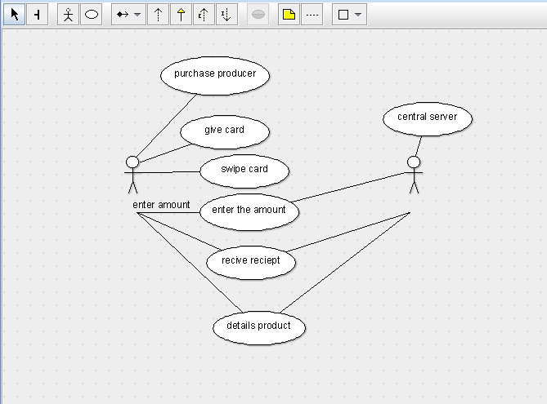

STATE DIAAGRAM

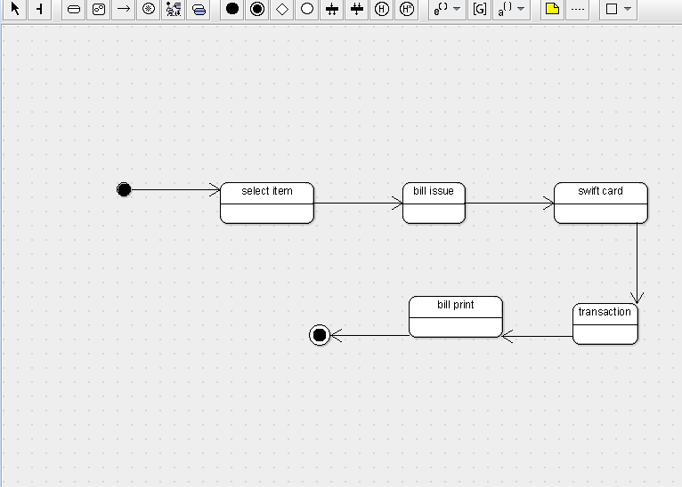

SEQUENCE DIAGRAM

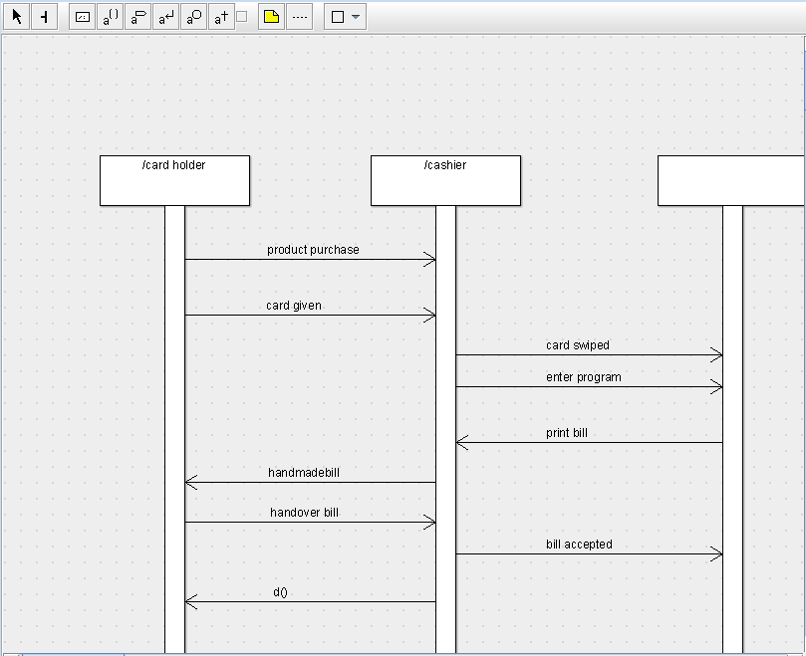

DEPLOYMENT DIAGRAM

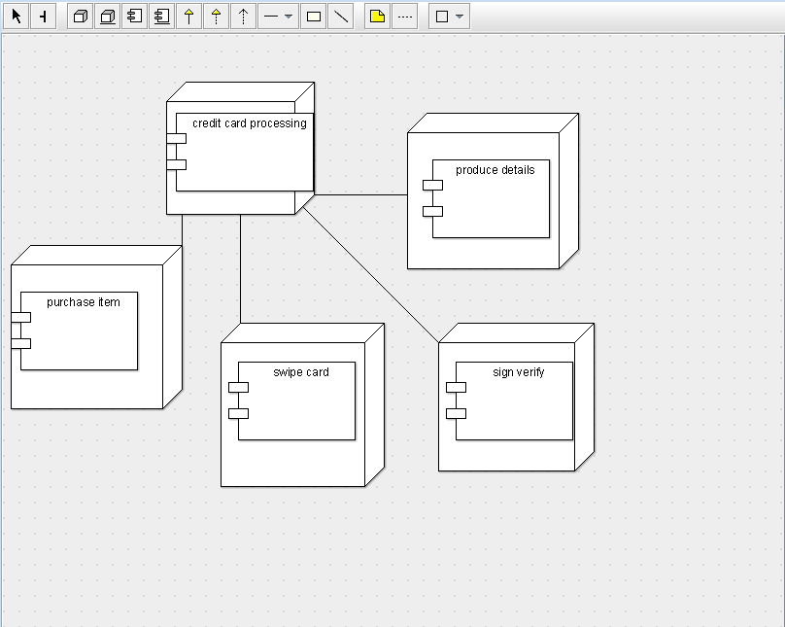

COMPONENT DIAGRAM

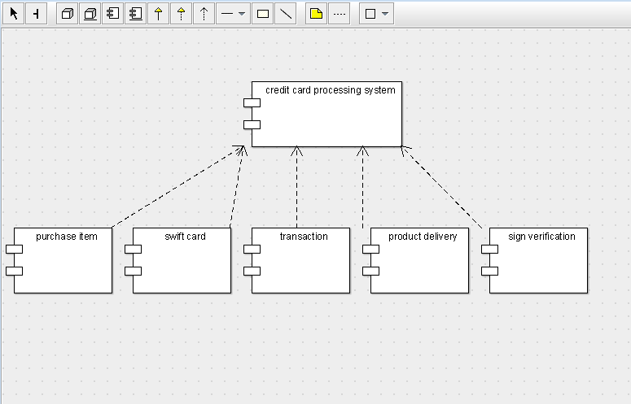

COLLABORATION DIAGRAM

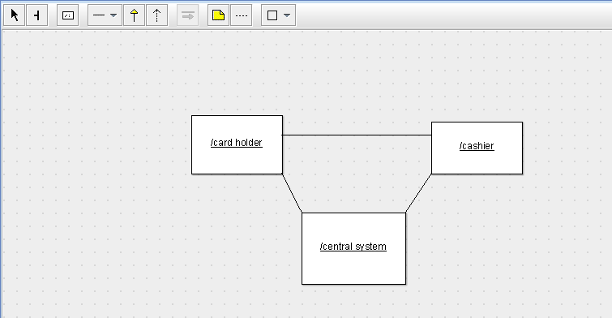

CLASS DIAGRAM

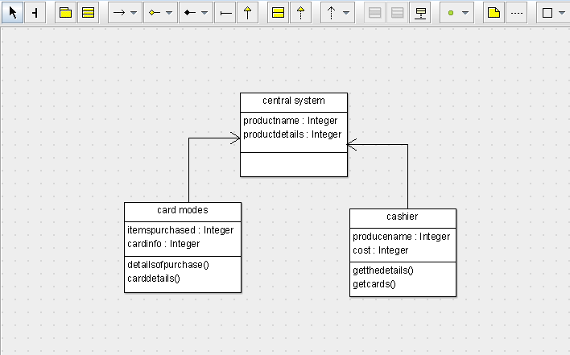

ACTIVITY DIAGRAM

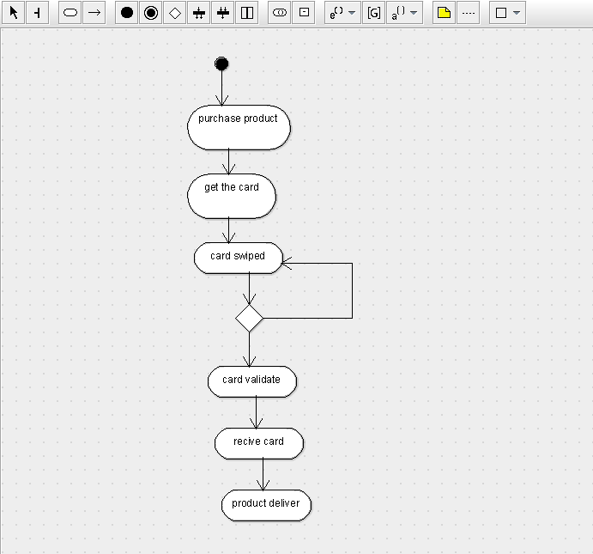

SKELETON CODE:

public class central system {

  public Integer productname;

  public Integer productdetails;

}

import java.util.Vector;

public class cashier {

  public Integer producename;

  public Integer cost;

    public Vector  mycentral system;

    public Vector  mycentral system;

  public void getthedetails() {

  }

  public void getcards() {

  }

}

public class central system {

  public Integer productname;

  public Integer productdetails;

}